Stages Workshops are designed to develop performance and technical skills. Acting, movement, creative thinking & problem solving, awareness of the world around us, and theatre technology will be explored. Activities led by skilled & experienced theatre personnel.

Workshops are held at Bay City Players from 10:00 to 3:00, Monday through Thursday. Performances will be August 1 & 2. Students must bring their own lunches.

Registration fee is $80 per student. Some partial need-based scholarships may be available. Apply for scholarship consideration by letter to Joanne Berry ([jmberryjm@aol.com](mailto:jmberryjm@aol.com) )

Registration forms/information soon at [www.baycityplayers.com](http://www.baycityplayers.com) or at Bay City Players, Monday –Thursday, 9:00 am – 1:00 pm.

**Registration deadline: July 8, 2019 or until all places are filled.**

**Stages of**

**Discovery**

**Summer Workshops 2019**

**July 15-18, 22-25 and July 29-31**

**Performances August 1 & 2**

**Open to students**

**completing 2nd**

**through 12th grades**

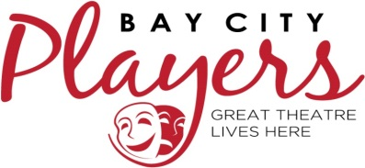

1214 Columbus Avenue, Bay City, MI 48708

989-893-5555 ● [info@baycityplayers.com](mailto:info@baycityplayers.com)